TASK 12 – Design Challenge: Extending the Smart-Parking System

Aim
To enhance the Campus Smart-Parking System by introducing new vehicle categories, special parking charges, visitor passes, and support for multiple floors with unequal slot capacities.

1. Proposed Enhancements
- E-bike parking: Charge a fixed flat fee for electric bikes instead of calculating the fee by the hour.
- Delivery van parking: Charge delivery vans twice the normal car parking rate between 9:00 AM and 5:00 PM.
- Visitor pass: Provide visitors with a one-day parking pass that is valid for one day.
- Five-floor parking: Extend the system to support five floors, each having a different number of parking slots.

2. Impact Analysis
Enhancement | Required Change | Expected Benefit
E-bike flat fee | Add a separate fee calculation rule | Simple and consistent charging
Delivery van rate | Check vehicle type and entry time | Supports time-based pricing
Visitor pass | Store pass validity and expiry date | Controls visitor parking
Five floors | Use a variable-size array for each floor | Supports unequal slot capacities

3. Modified Java Code
class ParkingFeeCalculator {
static double calculateFee(String type, int hours, int entryHour,
double carRate, double eBikeFlatFee) {
if (type.equalsIgnoreCase("E-Bike")) {
return eBikeFlatFee;
}
if (type.equalsIgnoreCase("Delivery Van")
&& entryHour >= 9 && entryHour < 17) {
return hours * carRate * 2;
}
return hours * carRate;
}
}
class VisitorPass {
String visitorName;
String expiryDate;
VisitorPass(String visitorName, String expiryDate) {
this.visitorName = visitorName;
this.expiryDate = expiryDate;
}

void display() {
System.out.println("Visitor: " + visitorName);
System.out.println("Valid Until: " + expiryDate);
}
}
public class Main {
public static void main(String[] args) {
double bikeFee = ParkingFeeCalculator.calculateFee(
"E-Bike", 3, 10, 50, 20);
double vanFee = ParkingFeeCalculator.calculateFee(
"Delivery Van", 2, 10, 50, 20);
System.out.println("E-Bike Fee: Rs. " + bikeFee);
System.out.println("Delivery Van Fee: Rs. " + vanFee);
VisitorPass pass = new VisitorPass("Arun", "17-10-2026");
pass.display();
int[] slotsPerFloor = {20, 25, 15, 30, 18};
String[][] parking = new String[5][];
for (int i = 0; i < 5; i++) {
parking[i] = new String[slotsPerFloor[i]];
}
System.out.println("Total Floors: " + parking.length);
}
}
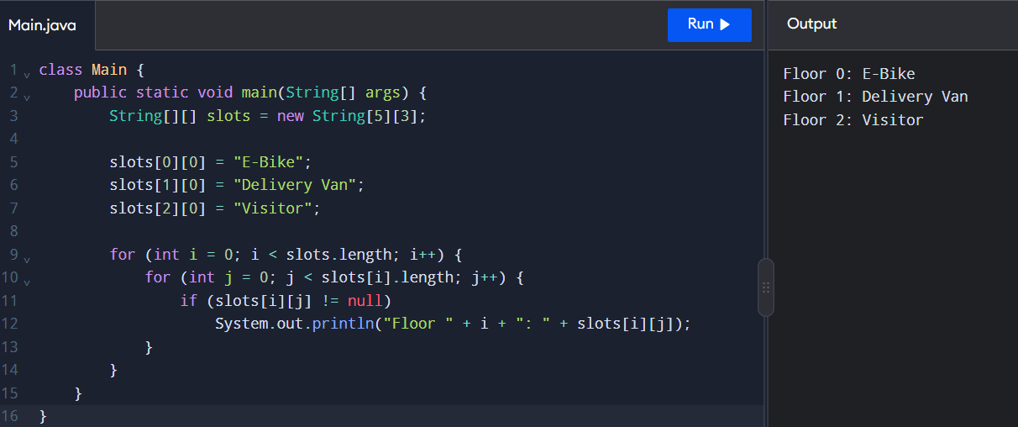

4. Expected Output
E-Bike Fee: Rs. 20.0
Delivery Van Fee: Rs. 200.0
Visitor: Arun
Valid Until: 17-10-2026
Total Floors: 5
Note: The example uses an e-bike flat fee of ₹20 and a car rate of ₹50 per hour. These are illustrative values, not specified rates from the assignment. The visitor pass example stores an expiry date; actual date validation must be added to enforce one-day validity.

5. Evaluation of the Proposed Design
- Maintainability: Separate fee calculation and visitor-pass classes make the system easier to update.
- Scalability: A jagged array supports five floors with different slot capacities.
- Flexibility: New vehicle categories can be added with separate pricing rules.
- Reliability: Visitor-pass expiry and parking-slot availability should be validated before granting access.
- Performance: Slot allocation using a sequential search takes \(O(N)\) time in the worst case, where \(N\) is the total number of slots.

6. Alternative Approach
Instead of storing parking slots in a jagged array, the system can use an ArrayList for each floor. This allows parking capacity to change dynamically. A HashMap can also be used to find vehicles quickly using their registration numbers.

Result
The Smart-Parking System was extended conceptually to support e-bike flat fees, time-based delivery van charges, visitor passes, and five floors with unequal parking capacities. The proposed design improves flexibility, scalability, and maintainability.

